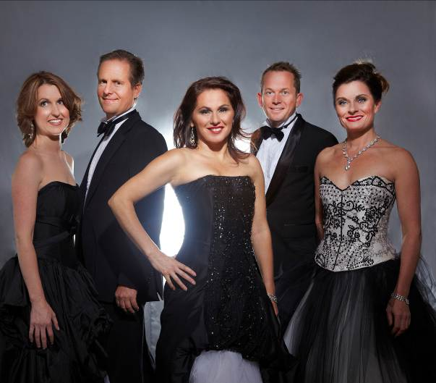
POT-POURRI

SHORT PROFILE
Pot-Pourri are regarded as one of Australia’s leading feature acts and are highly sought after on the corporate and conference stage as well as performing at major venues, concerts, festivals and events around the world. If you are looking for that perfect feature act guaranteed to bring down the house, then don’t miss booking Pot-Pourri! They will ensure your event is fun, magical, impressive and memorable and will leave your audience standing and singing out for more!

"Without a doubt Australia's best all-round musical entertainment group. A standing ovation every time!” Rotary International

Video link: https://www.youtube.com/watch?v=F5c3YBpoAQ0
Pot-Pourri flash mob video with over 700K views: https://www.youtube.com/watch?v=PzJTSh7jZw0

Key points

- Sensational voices, great humour

- Innovative, custom-designed musical and theatrical entertainment with a touch of opera, Broadway, cabaret, magic and comedy

- Regarded as one of Australia’s leading feature acts, Pot-Pourri customise their shows to include hits from favourite Broadway shows and musical theatre including Phantom of the Opera, Westside Story, Les Miserables and Chicago to operas including Carmen, Lakme, La Traviata, The Pearl Fishers and most loved songs by Leonard Cohen, Bocelli and the spine-tingling Nessun Dorma and Time to Say Goodbye.

- There is no typical Pot-Pourri show. Their program is individually and specifically designed according to the client brief, atmosphere, event and venue details. They write unique songs and lyrics for clients about topics as diverse as gynaecology, medicine, banking and cars!

- They have performed and received standing ovations at diverse events over 25 years in over 40 countries for Prime Ministers, Presidents, CEOs and other dignitaries at a huge range of gala dinners, awards nights, conferences, private parties and major special events. They have released 7 CDs

- Spectacular Australian group, Pot-Pourri in an unforgettable, new, entertaining and classy performance! Tailor-made for your special event.

Biography

Voted Australian Event Entertainers of the Year, sensational songsters Pot-Pourri have been wowing audiences around Australia and internationally on the concert stage and conference and event circuit. With a new line-up, look and show, 40 overseas tours and 7 albums under their belt, they are described as brilliantly talented, funny, fresh, moving and must-see....do not miss them! This is the show! Entertainment for all, entertainment at its best!

Pot-Pourri will create an unforgettable, new, entertaining and classy performance! Tailor-made for your special event.

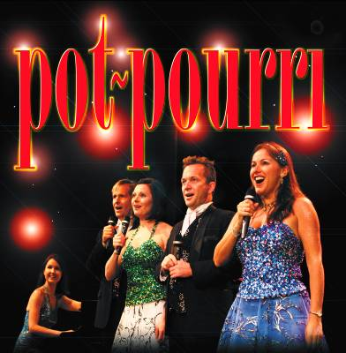
Pot-Pourri is Tania de Jong AM (soprano), Rebecca Bode (soprano), Jon Bode (tenor), Jonathan Morton (baritone) with Pianist and Musical Director Anthony Barnhill.

Their new shows are spellbinding, interactive and an uplifting celebration of the human spirit combining Opera, Broadway, Comedy, Cabaret, Didgeridoo, Dance, Acrobatics and Magic. Always full of surprises!
They have received standing ovations for a diverse range of clients, as well as performances at concerts and festivals around Australia and internationally including Opera in the Vineyards, Broadway under the Stars, their first performance at the beautiful Melbourne Recital Centre, Sydney Opera House and performances in China, Singapore, Japan, Italy, USA, Malaysia and Hong Kong.

Pot-Pourri is looking forward to creating a special, memorable performance for you with that unique WOW factor! If you have some events in mind, we recommend you book early for this talented Australian group. We guarantee your event will be talked about for a long time to come!
This is a sparkling and unique feature performance (plus encores!) featuring well-known hits from Opera to Broadway and songs from Phantom of the Opera, Les Miserables Westside Story La Traviata, Turandot, Carmen, Lakme, The Pearl Fishers and favourites and international hits from Leonard Cohen, IL DIVO, Josh Groban and Andrea Bocelli including Nella Fantasia, You Raise Me Up, Hallelujah, The Prayer and Time to Say Goodbye! These talented artists hit those high C's in Opera, belt out Broadway, seduce with song, dance up a storm, create magic and stir your soul with haunting ballads.

The diversity in the performance and the music and comedy crosses all boundaries of background, nationality and culture, and really helps to put the audience in a positive, celebratory and uplifted mood. The group can also prepare a special song and other material with lyrics related to the client and industry. As well, the artists will charm their way around the audience and your special guests with comical interactive moments. Pot-Pourri’s success is largely due to their ability to be innovative with traditional art forms and adapt to each unique audience. They are clever, fresh and creative thinking and will create a show that is memorable, funny and moving and can highlight a sponsor and/or special themes if requested.

Pot-Pourri has toured to sell-out houses both nationally and internationally and they are in constant demand giving public performances in festivals and major concert halls and providing feature act entertainment at special events. Their clients include many of the world’s largest corporations and organisations.

They were selected as one of the companies to represent Australia internationally for the Reaching the World program of The Sydney Olympic Games and were invited to perform at the World Expo in Hannover as a result of a standing ovation at the Australia Germany Association Conference Gala Dinner in Brisbane. They also performed as guest artists with the Seoul Symphony Orchestra in Korea. They launched their fifth album in a sell-out season at The Famous Spiegeltent at the Melbourne Festival and were the only Australian act invited to perform for the International Music Theatre Festival in Korea. Other recent tours include a sell-out season in Japan, Taiwan, performances in Italy and a major tour of New Zealand. Pot-Pourri was the first Australian act invited to perform at the Macau Cultural Centre in China and have given performances in Hong Kong for the Hong Kong Jockey Club and Government House, and their debut shows in mainland China.

COPY

Take 5 of Australia’s most talented performers....2 sopranos, a tenor, baritone and the most talented young pianist
Add a dash of opera
and a slice of cabaret,
Toss in your favourite Broadway hits
and a touch of class,
A hint of magic
and top it all off with a big dollop of comedy.
All served up with stunning voices, gorgeous harmonies and lots of fun
And there you have the sensational and superbly entertaining
POT- POURRI!

Experience some of the most magical musical moments of international song with one of Australia’s leading acts, sensational Australian group Pot-Pourri. The performance will favourite international and Australian songs from music theatre and opera including Carmen, The Pearl Fishers, Rigoletto, Lakme, Turandot, La Traviata, Phantom of the Opera, Les Miserables, Cats, Chicago, and global hits such as You Raise Me Up, Hallelujah, Nella Fantasia, Hallelujah, The Prayer, Nessun Dorma, Time to say goodbye, Amigos Para Siempre (Friends for Life) and We are Australian ....
Be transported by the glorious voices and theatrical skills of four of Australia's finest singer/actors, a brilliant pianist, gorgeous harmonies and glamorous costumes. These talented artists hit those high C’s in Opera, belt out Broadway, seduce with song, dance up a storm, create magic and stir your soul with haunting didgeridoo and ballads!

TESTIMONIALS

“Pot-Pourri received a standing ovation from a rapturous crowd of international delegates at the conclusion of their performance at Sydney Opera House. The five artists from Pot-Pourri have exceptional musical talent and an equally impressive ability to establish and maintain rapport with their audience. Their sense of drama and comedy kept everyone spellbound and begging for more!” Newmont Asia Pacific
"Music theatre of the highest calibre, brilliantly crafted, gorgeous voices and a great sense of fun. A standing ovation - don't miss them!”
The Canberra Times

"..unique, sensational, funny, brilliant!"
Australia Germany Conference

"Very positive response from the non-English speaking audience who enjoyed the unique blend of classical and Broadway music, a taste of Australia, beautiful voices, comedy and interaction."
Credia, Korea

"Without a doubt Australia's best all-round musical entertainment group. A standing ovation every time!”
Rotary International

"It was the best conference entertainment we have had in our 20 year history...the integration of concrete into the show was brilliant and the audience from all over the world spontaneously stood and cheered!"
International Concrete Conference

“Pot-Pourri was in excellent form at the Great Hall! Your choice of songs for your performance had universal appeal and was especially appropriate for our varied international delegate audience.
I would have thought it completely impossible to find any word which rhymed with endometriosis but your customised song – Supercalifragilistic-endometriosis – has become already an icon (symbolic) sensation for all of us who are members of the World Congress of Endometriosis and its affiliates!”
World Congress on Endometriosis
“Pot-Pourri received a standing ovation from a rapturous crowd of international delegates at the conclusion

